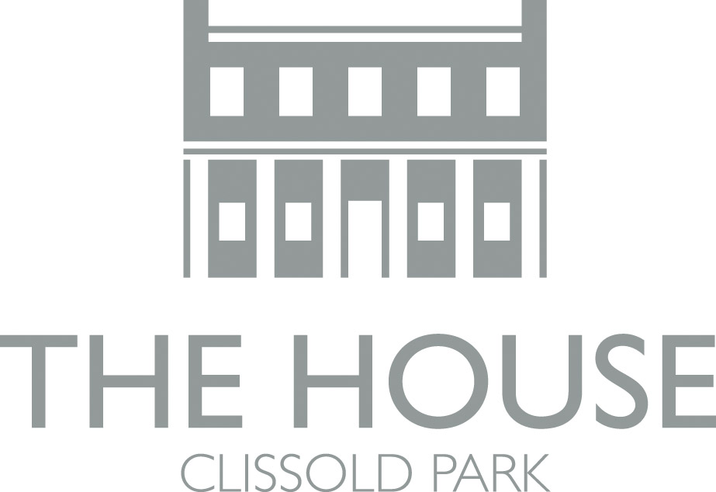

BREAKFAST
Served from 8.30am to 11.45am

Full English (with scrambled eggs) 8.95
Full English (with fried egg) 7.95
Vegetarian breakfast 5.95
Free range bacon or sausage sandwich 4.05
Granary toast & butter 1.90
Extra sausage or bacon 1.50
Extra tomato, fried egg or beans 1.00

LUNCH
served from 12pm

Free range chicken burger, sweet potato wedges 9.50
Chicken shish kebab 8.50
Falafel kebab 7.50

Soup with granary bread, cheese & fruit 6.60
Soup with granary bread 4.60

Baked Potato
Beef chilli 6.95
Tuna & chive 6.30
Cheese & beans 5.50
All served with red cabbage & apple slaw

12” Flat Bread Pizza
Tomato & mozzarella 6.50
Pepperoni 7.50
Spinach & Rosary goat’s cheese 7.50

SANDWICHES

Carrot, hummus, coriander seeded
bap (gluten free) 3.75
Tuna & chive mayonnaise 3.80
Free range egg mayonnaise & cress 4.05

Emmenthal & ham baguette 4.95
Emmenthal, rocket & tomato baguette 4.95

SALADS

Chicken Caesar 9.50
Mozzarella, avocado, basil & tomato 8.50
Greek salad 7.50
Fattoush 7.50

CHILDREN’S/
SMALL MEALS
served from 11am
Pick and mix lunch box 4.50
Penne with tomato sauce 3.55
Children’s tomato & mozzarella flat bread pizza 3.50
Cheese Sandwich 1.00
Ham Sandwich 1.00
Fairtrade calypso orange / apple juice 1.35

DRINKS
Three cup cafetiere 3.55
Americano 2.00
Espresso / double espresso 1.40/1.70
Cappuccino / café latte 2.15
Iced latte 2.55
Coffee syrups 40p
Hot chocolate 2.15
Pot of tea 1.75
English breakfast tea 1.65
Yorkshire Gold tea 1.30
Fairtrade teas & infusions 1.80

Still / sparkling water 1.65
Coca Cola/Diet Coca Cola 2.00
Homemade lemonade 2.50
Fresh orange juice 2.55
Pressed apple juice 2.55
Breckland Orchard elderflower 3.10

LAGER
Kronenbourg 275ml 3.70

WINE
Red, white & rose –
- 750ml bottle 16.80
- 125ml glass 3.85
- 175ml glass 5.05

Please place your order at the counter

