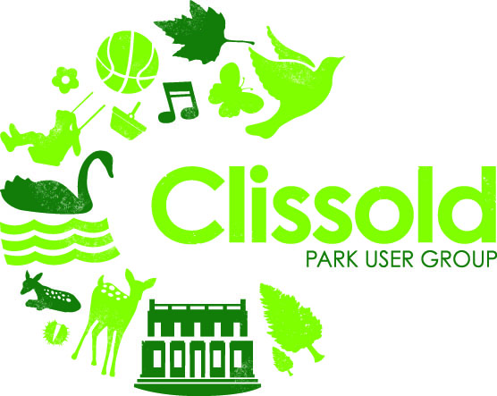
User Group Meeting 11 May 2011
AGENDA
- Apologies

- Minutes of previous meeting

- Matters arising

- Park Manager’s Report: (Elle Potter, Interim Park Manager)
- Park works updates
- New Head Gardener
- Volunteering
- Schools / other activity
- House
- Café
- User survey

- Cycling in the park

- Behaviour of older school children in the park and house

- Any other business

CHAIR’S REPORT

- Meetings, events, activities attended by CPUG officers and volunteers since last meeting
Date | Meeting/event | Attended by
18/3/13 | New River Meeting | CM/JH
21/3/13 | Hackney Parks Forum | CM/Liz Fewings
24/3/13 | CPUG quiz | Many!
23/4/13 | Exploratory walk to source of New River | Ken Worpole
23/4/13 | Volunteer photography for education programme | Larraine Worpole
9/05/13 | Clissold Park Development Board | CM/JH
9/05/13 | Meeting with Abney Park Trust to discuss joint working | CM/JH

- Communications: Thanks to Isabelle Gore, we now have a new website. You can subscribe to the newsletter directly via the website. We have also introduced a new electronic mail management system which is more efficient and easier to manage. 248 people have joined the Facebook group and 371 subscribers to our online mailings. There are 30 people who receive the newsletter by post, thanks to Betty Manning. We will be reviewing whether these people still want to receive it in this way.

- Fundraising: The Quiz in March sold out very quickly. Thanks to the hard work from Yvonne and Hilde and the generosity of those who bought tickets and contributed gifts for raffling and auctioning, we raised £850. In addition we will be receiving a contribution of £500 from Channel Four who were filming in the House on that day as compensation for our not having the room we had booked. Proceeds will go towards the restoration of the drinking fountains and the community event in September.

- Future CPUG events:

On Sunday 14th July (to be confirmed – NOT 9 June as previously proposed): As part of the celebrations of 400 years of the New River, Ken Worpole will lead a walk along the upper Lea and New River. We will meet at Hertford East station and walk to the New River source at Amwell and then to St Margaret’s before returning home. A total of only 4.3 miles (and all flat!) Full details to come but please tell us soon if you want to join us - numbers are limited.

On Sunday 29th September: We will be hosting a free family/community event to celebrate the 400th anniversary of the New River in and around the old bowling green area. Games and activities for all ages with a watery theme. We need lots of people to help out so please let us know if you are interested.

Future meetings: Saturdays 6th July, 7 September and 2 November 2013 at 11am.
Caroline Millar
Chair

