Clissold Park Biodiversity
Discussion Paper
For Clissold Park User Group
V2
9/12/2016
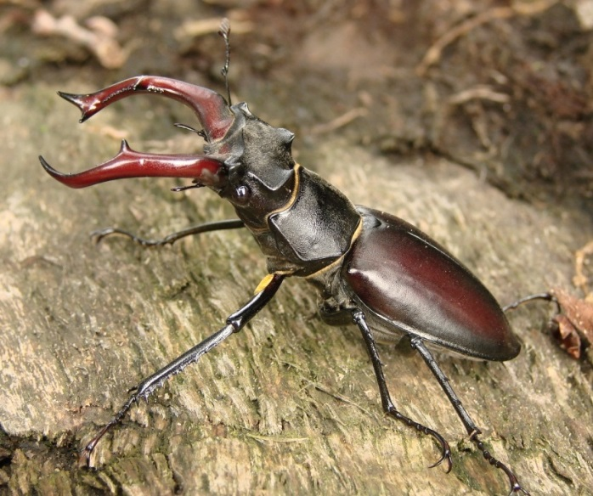

- Introduction
In October 2016, Clissold Park User Group requested a Biodiversity paper and recommendations to be presented to the group’s meeting for discussion on 12th November 2016.
A number of Officers and Partners including Michael Dixon - Parks Area Manager (South), Thomas Campbell - Senior Arboricultural Officer, Sam Parry - Parks Development Manager, Richard Crawford - CPUG Member, Annie Chipchase - Biodiversity Advisor, and Russel Miller - Tree Musketeers have contributed to this report.
Clissold Park forms a part of the London ‘Green Grid’ that connects the Lee Valley via Springfield Park and the Abney Cemetery Local Nature Reserve with Clissold Park, thus creating a wildlife corridor. Other important neighbouring sites include the Woodberry Wetlands, managed by the London Wildlife Trust, and the Abney Park Local Nature Reserve.
Clissold Park is a Site of Borough Importance for Nature Conservation Grade I. It features a number of habitats.
- Clissold Park Habitats

- Amenity and improved/grazed grasslands
- Wildflower meadow
- Broadleaved plantation woodland
- Mixed plantation woodland
- Parkland trees
- Dense scrub
- Tall ruderal
- Ornamental flower beds
- Allotment/Growing Communities site
- Open water and marginal vegetation including reed beds, the New River, two lakes
- Log piles
- Hedgerows
- Bare ground
- Hard standing
- Buildings

- Hackney BAP – Extracts from Hackney BAP
The management of the park for biodiversity has to be considered in the context of the borough’s Biodiversity Action Plan. Hackney’s Biodiversity Action Plan 2012-2017 includes a Parks and Green Space Habitat Action plan.
- Hackney BAP - Vision
The Parks and Green Spaces BAP seeks to:
- Monitor, maintain and increase the biodiversity resource provided by parks and green spaces through appropriate site maintenance and biodiversity enhancements
- Ensure parks and green spaces contribute to a network of green infrastructure in Hackney
- Promote the importance of parks and green spaces in providing opportunities for access to the natural environment for Hackney’s residents.

- Background
Hackney’s wealth of parks and green spaces is often cited as one of the borough’s best assets. The Council manage 58 parks, ranging from small pocket parks to large areas such as Hackney Marshes. There are seven priorities for the management of parks, including biodiversity:
1. Children and Young People
2. Planning for the future
3. Conservation and biodiversity
4. Tree Preservation and Management
5. Activities and Events
6. Feeling Safe
7. Green Corridor
Hackney has approximately 106.4 people per hectare, making it the third most densely populated borough in the country. Although we have a large amount of green space, the population density and lack of private outside spaces mean that public parks play a vital role.
- Current Status
The Hackney Core Strategy states that we have 467ha of open space, of which 381ha is parks and green spaces (including sacred spaces). Many of our parks have defined areas for biodiversity and there has been significant progress over recent years.
The BAP does not include wooded areas or water bodies in parks as they are dealt with in other action plans. The main habitat types present in the GiGL audit that will be found in parks are amenity grassland, neutral grassland and hedges.
The following protected and priority species recorded in Hackney could use parks and green spaces for some or all of their life-cycle:
- Native black poplar  - Wall bedstraw  - European turtle dove  - Sky lark  - Dunnock (Hedge Accentor)  - Song Thrush  - Spotted flycatcher  - Common starling  - House sparrow | - White-letter hairstreak  - Wall butterfly  - Small heath butterfly  - Hedgehog  - Bats  - Common toad  - Stag beetle  - Grass snake
The Turtle dove and skylark are unlikely ever to use Clissold Park. However, other birds on this list already use the park: dunnock, song thrush, common starling, house sparrow, albeit in small numbers.
Common toads, newts, bats, foxes and grey squirrels are also present.
- Factors Affecting Parks and Green Spaces
Hackney’s parks and green spaces provide many services and facilities for different groups - sports players, children and carers, event organisers, nature conservationists and those wishing to enjoy quiet open space. The multiple roles that parks play is the reason that they are so important; however it also means that their management should be carefully balanced to reflect the different priorities. The best way to ensure that biodiversity thrives in our parks and green spaces is to make it integral across sites. It is more beneficial to have sensitive mowing regimes and biodiverse planting throughout a site than to have a small ‘wildlife corner’. Wildlife lawns can be used as an alternative to amenity grassland in areas where grass needs to be kept short.
The delivery of appropriate management is dependent on maintenance staff and contractors having appropriate skills and knowledge. Training on biodiversity management is an integral part of the BAP and is one of the key issues to ensuring its success.
There is sometimes a perception that biodiverse sites are untidy and can result in complaints from the public, for example about long grass not being managed. It is important that Hackney parks are maintained to the standards expected by our residents and management regimes should reflect this. Methods such as mowing strips around the edges of wildflower areas show that they are being managed. Interpretation and engagement can also be used to communicate the reasons for maintenance changes.
There has been an increased interest in food growing in urban areas. A number of Hackney’s parks now contain orchards which provide public benefit and food as well as creating valuable habitat. Traditional orchards are a UKBAP Priority Habitat and can support a range of species, such as the nationally scarce red-belted clearwing Synanthedonmycopaeformis.

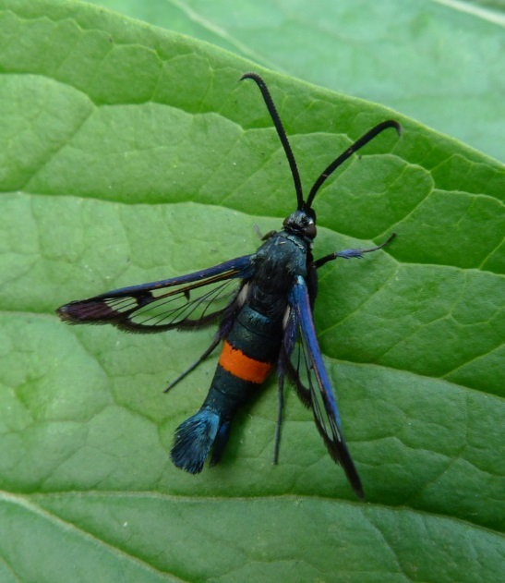

- Parks and Green Spaces Flagship Species

Flagship species have been selected as examples of species that people may recognise and be able to relate to. Target species are those that may be less well known but important to the biodiversity of Hackney. Some target species have been recorded in Hackney whilst others will be encouraged through appropriate actions and management. Both target and flagship species are addressed in the BAP and are considered as Hackney Priority Species.
Flagship Species | Description
Stag beetle  (Lucas cervus) | Britain’s largest terrestrial beetle. Numbers have declined nationally since the 1940s. Needs dead wood to complete life-cycle.
Green woodpecker  (Picusviridis) | Largest of the three British woodpeckers. Climbs up tree trunks and branches. Often seen in parks and present at Clissold park.
Target Species | Description
Slow worm  (Anguisfragilis) | A legless lizard so it can be mistaken for a snake. Likes open or semi-open habitats. Often found sheltering under wood or stones.
Blackthorn  (Prunusspinosa) | Deciduous large shrub with stiff, spiny branches and creamy-white blossoms. Foliage is eaten by a number of moth species.
Song thrush  (Turdusphilomelos) | Blackbird-sized bird with distinctive spotted chest. Numbers are declining seriously.
Seraphim moth  (Lobophorahalterata) | Speckled moth that flies from May to June. Larvae feed on aspen and poplar.
Common blue butterfly  (Polyommatusicarus) | Commonest blue butterfly found in Britain. Found in a variety of habitats including unimproved grassland and verges.
Bats | At least 9 species of bats are known to live in Hackney in our built environment and open spaces. All species of bat are protected through legislation due to a decline in their population.
Green woodpecker, song thrush, jays, foxes and bats all use the park.
Grey squirrels also use the park although they are not native to Britain.
Some rare Willow Emerald Damselflies were spotted on the New River by a London Wildlife Trust surveyor as part of their Water for Wildlife Project in November 2016. They are a recent arrival to England and this was the first time the species was recorded in Inner London.

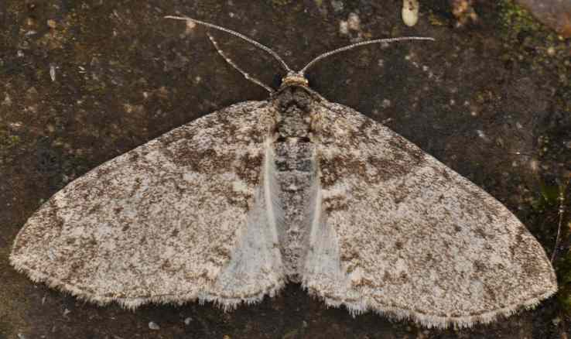
Seraphim moth c. Matthew Gandy
- Biodiversity borough wide targets include:
Increase the biodiversity value of parks and green spaces. This will include:
- 10,000 m2 wildflower meadow
- 1 km native hedgerow
- 30,000 native bulbs
- 30 insect loggeries

Targets are needed for tree planting at Clissold Park.

- Clissold Park – Management recommendations – December 2016
10.1 Rationale
These prescriptions are suggested as a means of increasing the biodiversity of Clissold Park. The park supports a variety of habitats, but there is scope for improving their value for wildlife and attractiveness to people. In most cases, this is down to sensitive and appropriate management and understanding target species’ lifecycles.
10.2 General recommendations
10.3 Grassland areas
Amenity grasslands
The majority of the site comprises regularly mown Amenity Grassland that is of limited ecological value. Grasslands in the park consist of short-mown areas and those where mowing is less intense (mainly around perimeters). Close-mown grass is clearly desired for sports use and general recreation, but there is scope to relax mowing regimes in certain areas. Less frequent mowing allows herbs and grasses to flower and set seed, thus providing a foraging resource. Increased floral diversity and density attracts species, including pollinators, such as butterflies and bees.
Periods during the summer months are getting hotter and during this time it is recommended that mowing is relaxed across all areas. Grass-cutting when there is very little growth results in parched areas that suffer from desiccation and compaction. Longer grass retains more moisture and can continue to grow (the grass does not have to be very long, a few centimetres can be sufficient).
- Mowing regimes – reduced mowing will increase the value of the grassland habitat. It can be tailored to suit different areas, the most frequent cuts being on areas of high recreational activity. Annual or biannual cuts would be appropriate in other areas.
- An annual cut is already being implemented as part of the more relaxed mowing regimes, for example, along Green Lanes.
It should be noted that reducing the frequency of mowing in productive areas could result in a more difficult mowing session the next time around and having to dispose of bulky arisings.
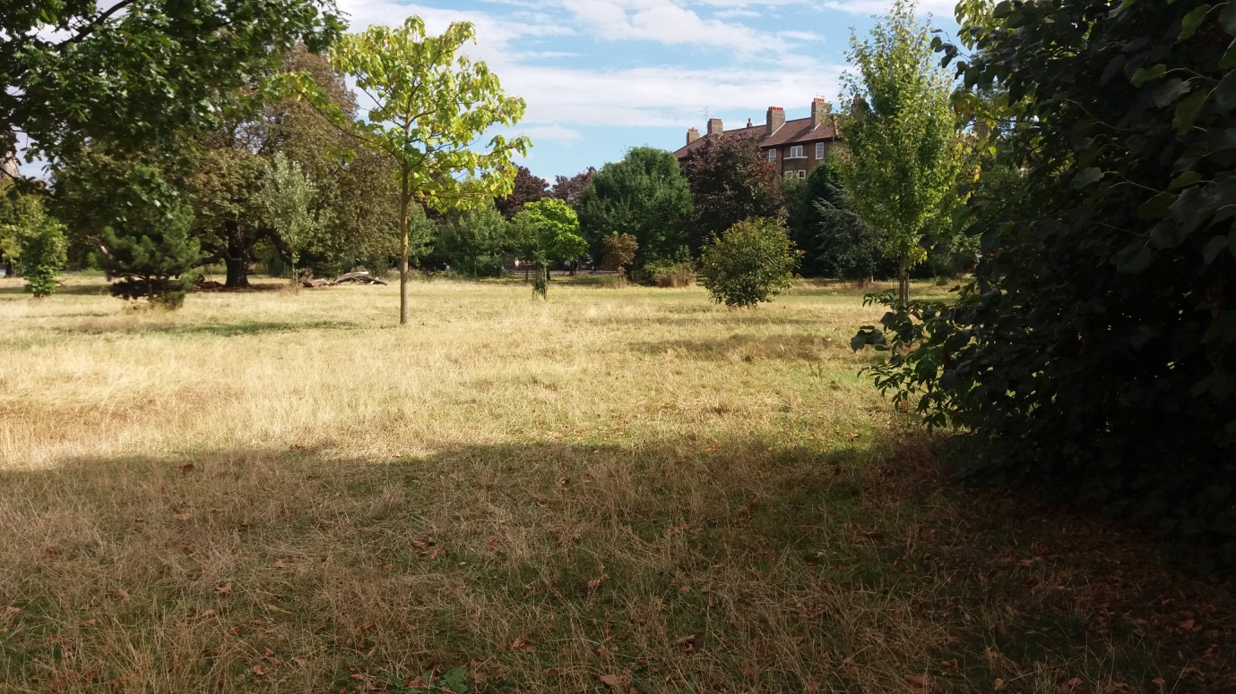
10.4 Improved grassland
The deer enclosure is grazed by the deer and regularly fed with manure (improved) to ensure good quality grazing for the animals. This area is dominated by common grass species and nettles. We are advised by the vets looking after the welfare of the deer that the grass sward is healthy and not overgrazed. We have organised feeding with manure in the autumn to ensure a healthy sward and plenty of food especially in the light of the deer management which is underway; the older animals from the herd were retired to a deer park in Devon whilst young animals (7 new animals in total, one buck and 6 does) were introduced in December 2016.
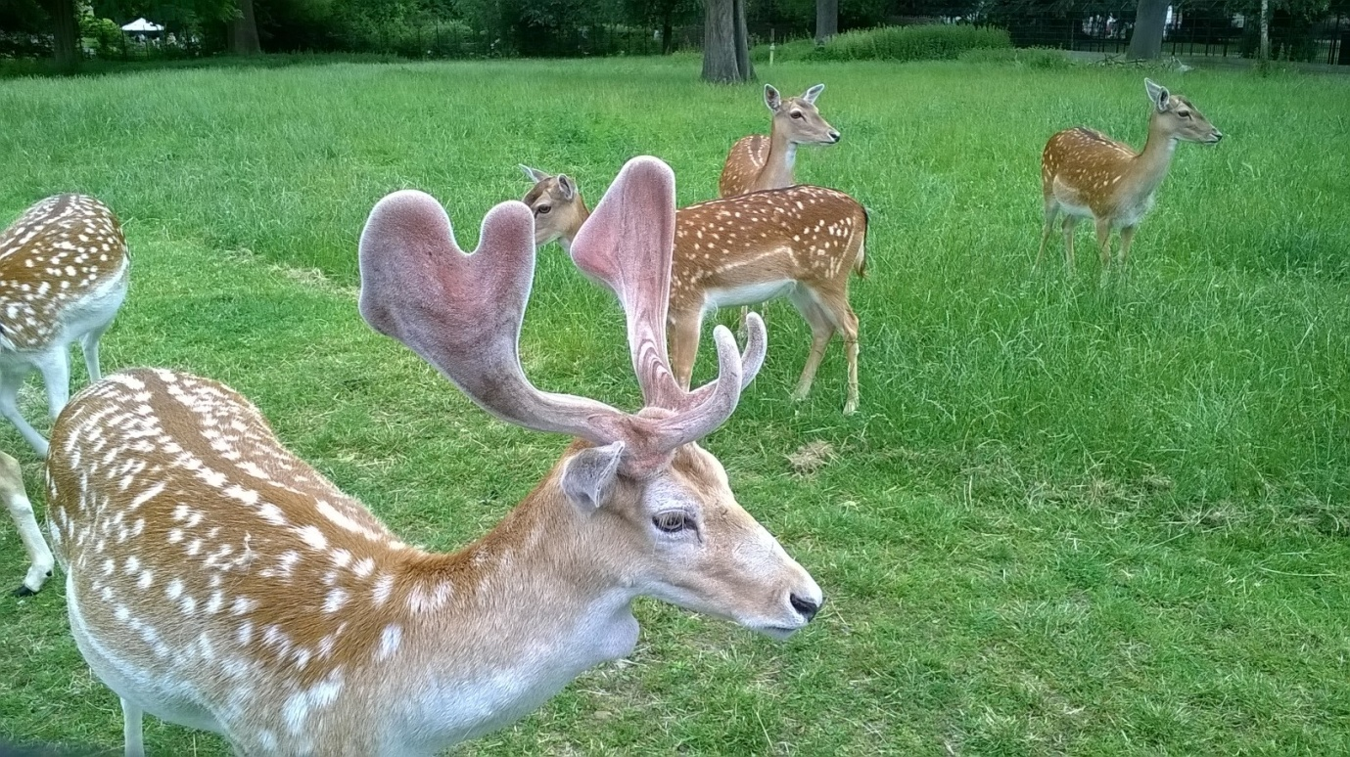
10.5 Wildflower areas
There is a wildflower area by the New River. This is delineated by Chestnut fencing and establishing.
A new wildflower meadow has been prepared along the path leading to the pump house.
10.6 Trees and Shrubs
10.7 The following habitats are present;
- Broadleaved plantation woodland – Along the woodland track by the Northern boundary/lakes
- Mixed plantation woodland – To the East of the Lodge
- Dense woody scrub – to the south of Runtzmere lake
- Parkland trees – around 1000 trees.
10.8 Management of existing habitats/species
- Shrub beds – remove self-sown seedlings and saplings and where there are sufficient gaps, plant shrubs/perennials, as appropriate.
- Remove suckering Robinia and Snowberry Symphoricarpos albus. Plant gaps with flowering shrubs.
- Minimise areas of bare soil. Soil should be protected by groundcover species, mulch, leaves etc. Blowing leaves out of shrub beds should be avoided as these protect and feed the soil and harbour insects.
- Newly planted trees and shrubs need attention and aftercare to ensure survival and healthy growth. Regular watering following planting is essential, along with mulching and ensuring the bases stay weed free.
- There is a need to identify where mulching might be feasible – For example, this is an issue where trees are surrounded by footpaths and other hard structures.
- Remove suckering growth from base of specimen trees. This is not necessary in woodland settings.
- Deadwood in all its forms provides valuable habitat for invertebrates and, thus, birds. Deadwood, standing, lying, below the tree canopy, in the open, provides different conditions and, therefore, supports different suites of species.
- Deadwood will be removed in close proximity to footpaths where a significant Health and Safety hazard would be presented by its retention.
- Remove some of the suckering poplar; relax mowing at the bottom of Queen Elizabeth Walk.
- The Council’s Senior Arboricultural Officer is planning some large scale pruning of many of the park’s trees in 2016. The programme is due to start in December 2016.
- All park vehicles are to avoid driving within the perimeter of tree canopies to prevent root damage and compaction.
- The park’s 20 best trees have been identified for a CPUG interpretation project. These should be carefully managed where possible including mulching and feeding.
10.9 Tree and shrub planting
New tree species for planting can be selected for flowering and the provision of pollen/fruit/seeds. Species selection should consider local conditions including heavy London Clay, compacted soils, tolerance to water logging or severe drought depending on the area in the park. Ornamentals could be considered including Mediterranean species. BAP species must be prioritised where it is believed they might thrive. Black Poplar, American Buckthorn, Japanese Chestnuts, Indian Chestnut, Serbian Spruce, Evergreen Oaks which are thriving in the park could be considered.
Many of the park’s trees are struggling. Park Horse Chestnuts and Sweet Chestnuts are very diseased and in poor condition, many of the park’s older trees show signs of stress, fungus infestation and damage by parasites.
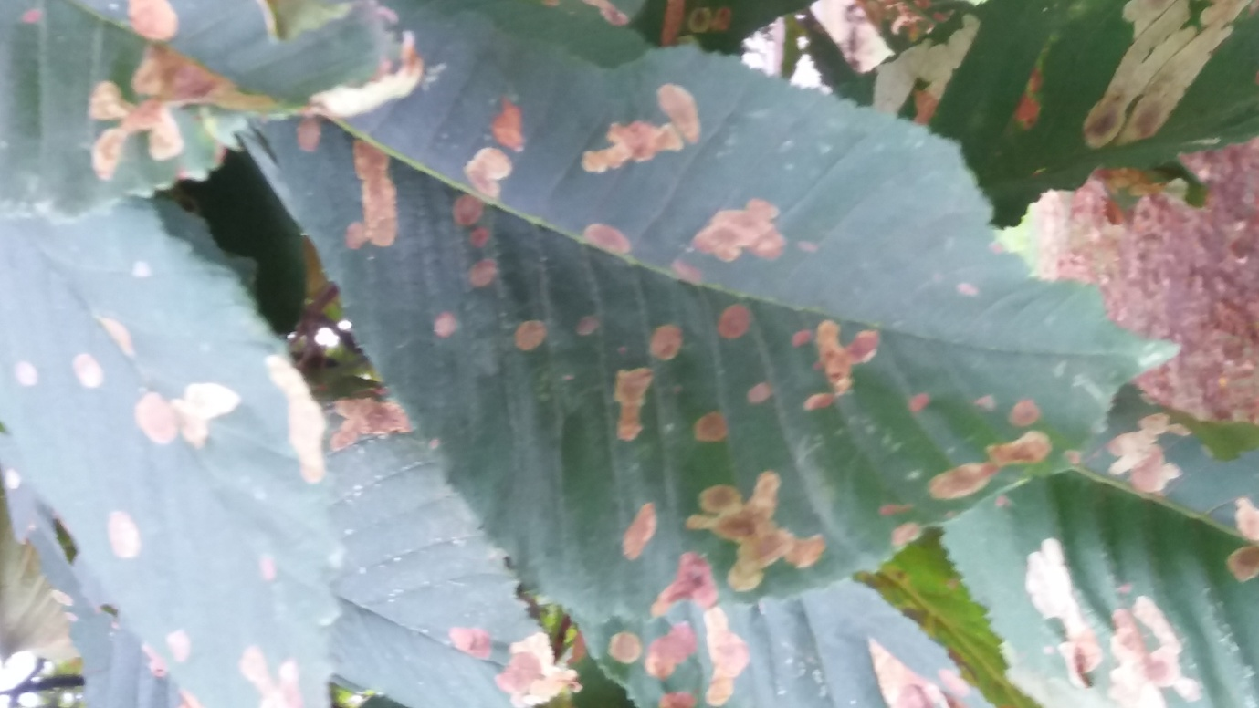
Ploughing or other measures to reduce compaction and enable roots to penetrate and access water and nutrients could be considered. Hackney Events Team currently does not allow any vehicles within the perimeter of tree canopies to prevent root damage and compaction.
Some areas have been identified for tree planting. A map will be produced. There is a need to consider tree succession including the tree avenues and which native trees are currently doing well or not. There is a need to consider short, medium and long lived trees. There is an urgent need to create a target/commitment to replace failed and recently removed trees as the park’s aging tree resource desperately requires succession planting.
Mulching around the base of existing and new trees must be considered as well as mulching around the base of the park’s 20 best trees.
Six memorial trees will be planting in 2016.
  - Along Stoke Newington Church Street:

- Plant groups of shrubs along running track where feasible. This area is very narrow and this may be challenging. This could be done by Tree Musketeers.
- Removal of the numerous saplings of Locust tree Robinia pseudo acacia below the trees was recently undertaken (Autumn 2016).
- This needs to take place on Becksmere Island also.
- Large patches of nettles and thistles can be cut as part of the mowing regime or used to locate dead wood.
10.11 Leaf management
Careful leaf management could be considered to feed and improve the ground. Leaves should be left in situ where possible to avoid depleting the ground of nutrient and removing insects from the park thereby reducing biodiversity. Invertebrates use leaves at all stages of their lifecycles and play an important role in their decomposition.
This needs to be auctioned ASAP with trials in suitable areas to improve tree health by leaf litter retention upon root plates.
Leaf mulch to be kept in the composting area.

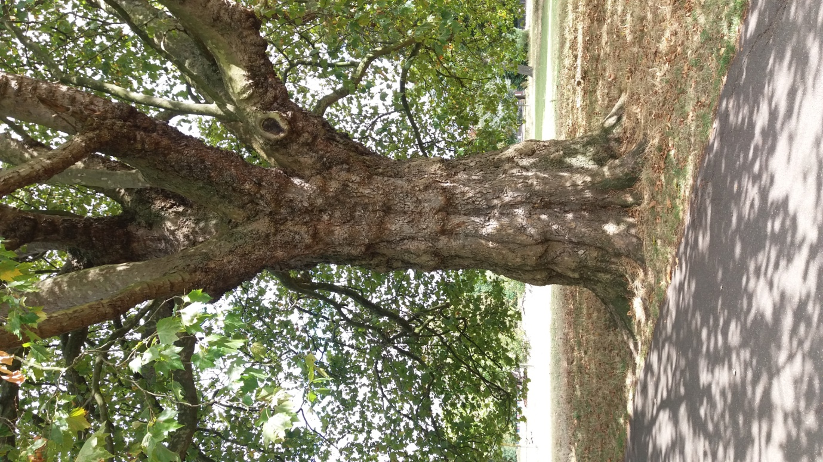

10.12 Tall ruderal – Dominated by Nettle or Creeping Thistle - Under woodland canopy - North and south of Runtzmere
The woodland track - There are numerous opportunities for shrub planting along the sides of the woodland track where nettles currently dominate. Before planting, cut back nettles and remove arisings, leaving any suckering or self-sown species, e.g. dogwood.
It would be beneficial to continue to add dead wood within the scrub.
There is a lot of bare, compacted ground below the trees along the north side of the path. Deadwood can be stacked neatly further in below the trees, as opposed to the edge of the path and grass cuttings can be placed there too. The area at the west end of Runtzmere on the north side has been planted with native shrubs, which now need management to maintain a dense scrub/shrub area;
- Remove fallen branches and sycamore saplings
- Crown-raise lime and poplar to increase light
- Reduce height of planted shrubs.
10.13 Ornamental flower and shrub beds
Mulch shrub beds, remove self-sown seedlings, e.g. buddleia, sycamore etc. Increase shrub planting.
Farmyard manure was applied to these areas and then topped with bark chips.
The large bed in the Pleasure Gardens was dug up in August 2016 to make way for an underground water tank. The flower bed will be reinstated according to the original planting plan in spring 2017.
10.14 Along Queen Elizabeth walk
The horizontal hedges need to be managed as such so they do not develop into trees. Starting with the more mature sections they can sequentially be cut back or coppiced to encourage growth from the base and create a denser hedge. New trees planted in this area may not thrive as it is shaded and the ground very compacted, although Elm trees between the fence and the horse chestnuts (Q E Walk was formerly called Elm Walk) could be considered. Consider succession planting of Elms or Oak in view of the poor condition of the Horse-chestnuts. The succession of the damaged Horse-chestnuts needs to be a priority. Some young trees could be provided by the Tree Musketeers. Bulbs can be planted in this area.
10.15 Earth mound by MUGA
This is not currently managed. Annual cut on mound. Plant aromatic herbs, e.g. Wild marjoram Origanum vulgare, Coriander Coriandrum sativum, Thyme Thymus species, on the steep west-facing bank. Species requiring full sun are ideal for these sloping banks, e.g. Anise hyssop Agastiche foeniculum, Bergamot Monarda didyma, Hyssop Hysoppus officinalis.

10.16 Open water and marginal vegetation including small reed beds, the New River, and two lakes
The margins of both lakes are very narrow. Wildflower seeding has taken place in the past and there are a number of surviving species. The shrubs and tree saplings colonising the margins should be removed by cutting to the base and repeated annually, although Willow and Alder should be retained.
The islands in the middle of the two lakes provide an excellent habitat for roosting and nesting wildfowl and birds. This is particularly important as the lake margins are narrow and provide minimal nesting opportunities. A visit to the islands took place in November 2016 to determine the best management strategy.

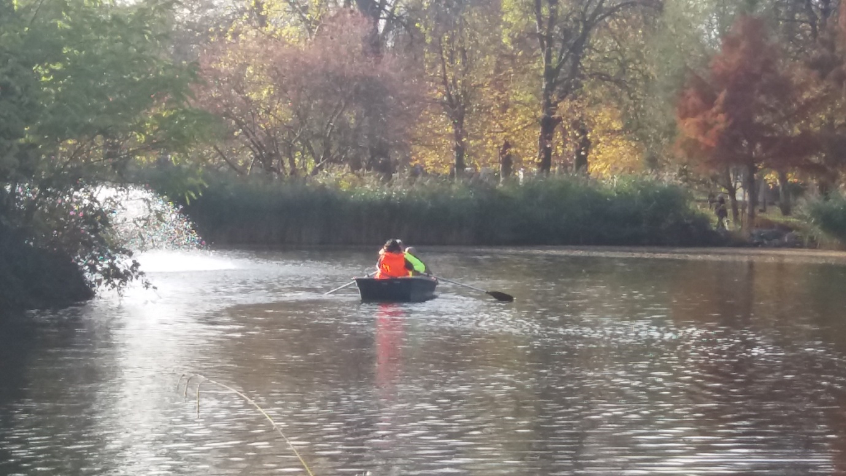
Some years ago, the wildlife trust constructed some floating platforms which were to double up as duck platforms / marginal planting structures, these did not fare well. The fresh vegetation may have been grazed by the wildfowls.
10.17 Runtzmere (Small Lake)
- Remove bramble and saplings (buddleia, horse-chestnut) from the surrounding bank.
- Prune and retain Willow and Alder
- Plant up the more open areas with wetland-associated species, e.g. Water mint Mentha aquatic, Soft rush Juncus effusus, Brooklime Veronica beccabunga, Ragged robin Lychnisflos-cucculi, Sedges Carex spp.
- Increase marginal vegetation planted in coir rolls or rafts made of branches e.g. Branched bur-reed Sparganium erectum, Yellow flag Iris pseudacorus, Common Reed Phragmites australis.
- Increase number of nesting platforms for wildfowls.
- This lake’s island is the smallest. It is quite inaccessible with dense growth. It has a variety of attractive trees and shrubs including willow, ash, roses, lilac, evergreen and sessile oaks, hawthorn, buddleia, privet, Michaelmas daisies.
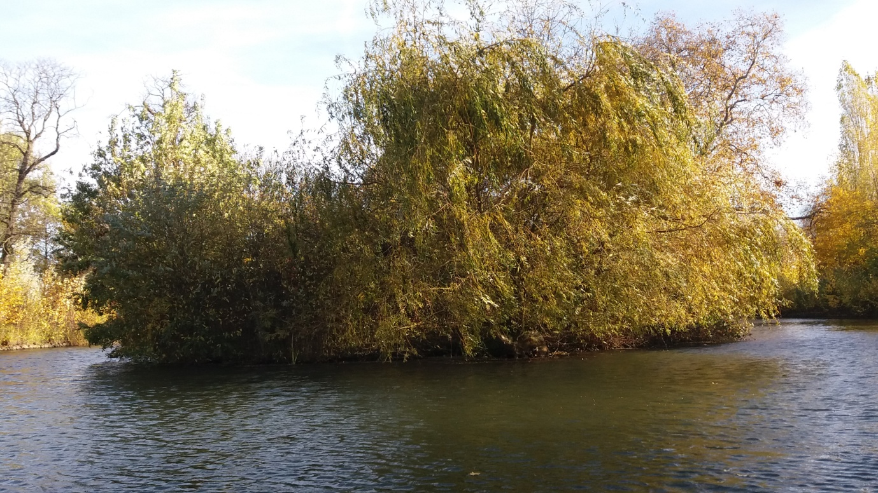

Management recommendations for Rutzmere island:
Clear out bramble, clear edges to enable access by birds, take out some of the trees old growth, and remove some ground vegetation.
Trim back edges/margins in January to March.
10.18 Becksmere (Large lake)
- Remove saplings from margins.
- Prune and retain willow and alder
- Increase area of reed at west end with coir rolls or rafts made out of branches.
- Margin along the south side – where dominated by nettles, cut these back and plant with Yellow flag, Sedges and Rushes.
- This lake’s island is dominated by Robinia pseudo acacia with a few large trees of this species suckering all over the island. Ivy dominates the ground cover. There is little light reaching the ground. There is also dogwood, bramble, laburnum, elder, alder, box tree, buckthorn, clematis. All the trees are covered by ivy and are not thriving.
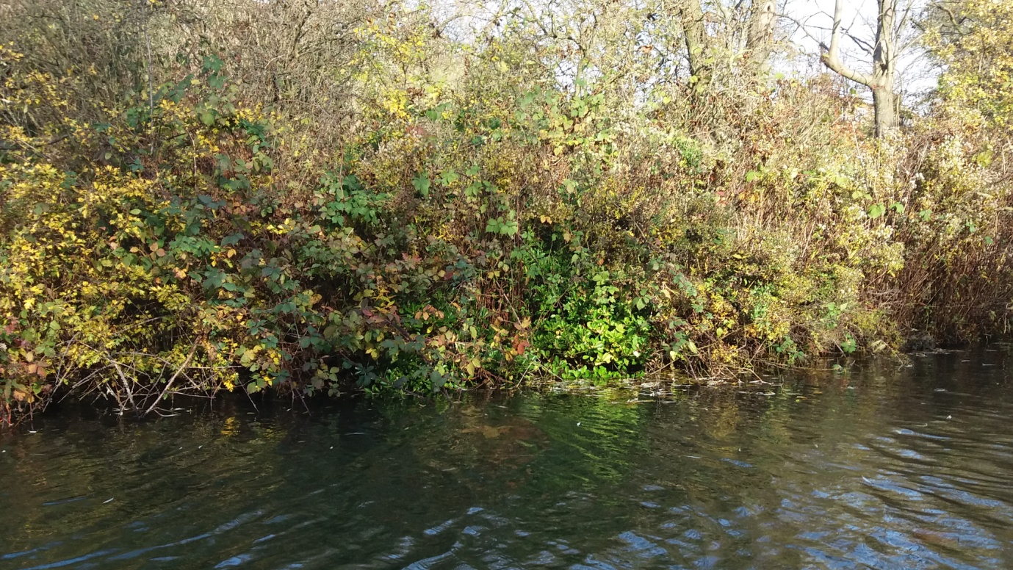

Management recommendations for this Island:
- All Robinia suckers should be taken out.
- Keep most of the mature trees but plant new ones to promote diversity.
- There is a need to severe ivy from the bottom of the trees to give them a better chance to thrive.
- There are surprisingly limited opportunities for bird nesting. This would be improved by thinning the Robinia to create more of a mosaic of habitats and encouraging more diversity.
- The Arboricultural Officer to mark out the trees to be removed.
- Create large wood piles. No materials to be removed from the Island.
- Some twigs and trunks could be formed into rafts for nesting birds.
- Some tree planting could be considered to include euonymus, laburnum, field maple, hawthorn, spindle, oak, willow, alder, swamp cypress.
- Do this work in the autumn and winter and stop all activity in the spring.
Predation of new-born ducklings, coot and moorhen chicks by lesser black backed gulls remains an annual problem. Only very few chicks survive predation at present. There is an urgent need to increase the reed growth at the margins of the lakes to ensure that there is cover for chicks in the spring, otherwise the death toll will remain high.
Rats can be controlled by preventing visitors from feeding bread to the ducks. New signs have been ordered.
Reed beds attract reed warblers (annual visitors) and cettis warblers (present for the whole of summer four years ago) thus increasing biodiversity.
10.19 New River:
Thin the Crack willow to allow more light, manage duck weed (these disappear in the winter), and plant herbaceous species among the rocks.
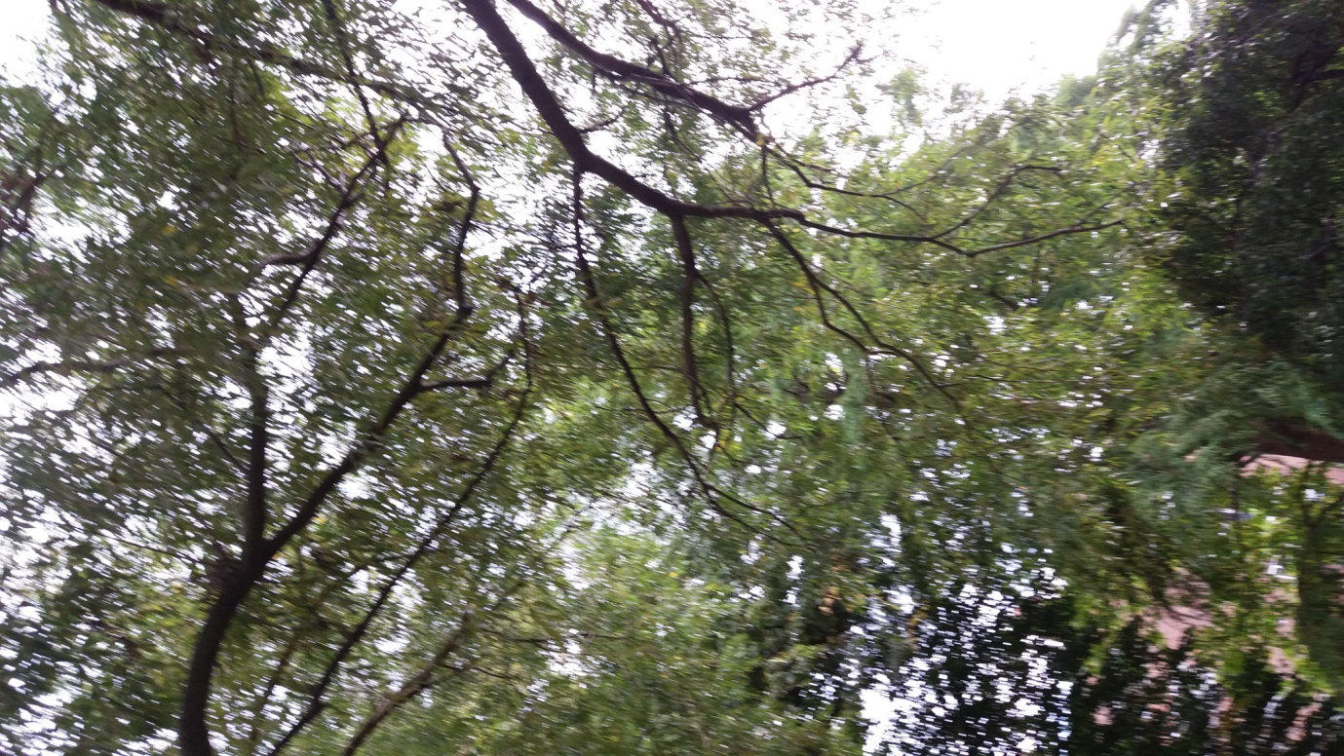
The new river could benefit with some more marginal vegetation as long as it does not become an issue to maintain it. The biodiversity recommendations should tie in with whatever is agreed with regard to the stocking or non-stocking of the park’s water bodies with fish. Reed management should be undertaken to retain open water. Biological control for duckweed could be considered.
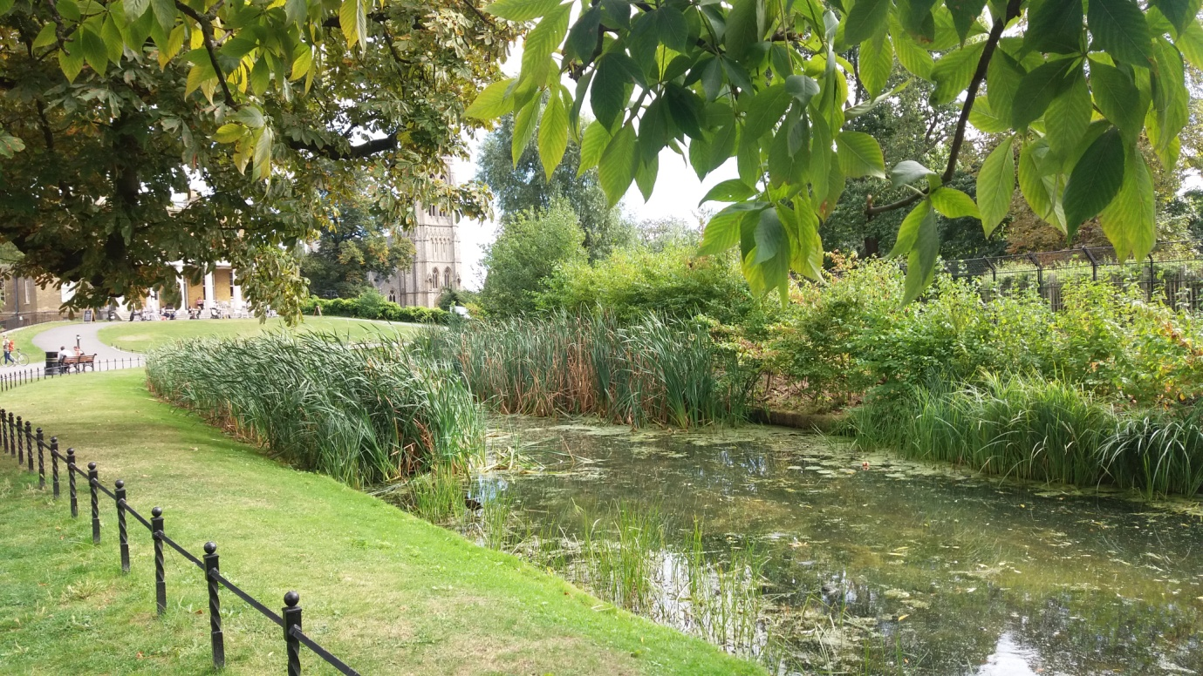
Rubbish is a constant problem. It is unsightly and dangerous to wildlife. Bottles, cans and litter should be removed regularly from the New River, especially by the bridge nearest to Church Street.
Owners regularly allow their dogs to swim in the New River, disturbing wildlife and potentially fouling the water. Some way of discouraging owners from allowing their dogs to swim in the new river would be desirable; for example, a more substantial fence although this is unlikely to be favoured as additional fencing is not in keeping with the park landscape.
10.20 Bowling Green
The job to tidy-up the raised beds and plant with a variety of aromatic herbs was previously done by the Outdoor Education Officer. This area is not currently being maintained and this work could be led by volunteers.
10.21 Suitable species of grasses and bulbs for future ordering and planning
Currently, 20,000 + bulbs are planted in the park every year. These include Crocuses, Galanthus, Hyacinth, Narcissus, Tulips. In order to increase interest for insects and birds, the following species are recommended.
Winter aconite Eranthis hyemalis
Primrose Primula vulgaris
Sweet violet Viola odorata
Common dog-violet Viola riviniana
Wood anemone Anemone nemorosa
Ground ivy Glechoma hederacea
Greater stitchwort Stellaria holostea
Wild strawberry Fragaria vesca
Ramsons Allium ursinum
Oxlip Primula elatior ( likes damp conditions)
Bugle Ajuga reptans
Lords-and-Ladies Arum maculatum
Stinking iris Iris foetidissima

- Butterfly dome and area around the dome
The butterfly dome and area around the dome will be planned and re-developed from spring 2017 as a native butterfly area. Plants for all stage of the butterflies’ lifecycle will be considered with a focus on BAP species. Flower borders, meadows and hedgerows will be considered for improvement. Butterflies are attracted by nectar rich flowers whilst the caterpillars need nourishing leaves often from different plants. A good nectar garden will contain a range of plants which flower during spring, summer and autumn.
Log piles and suitable planting outside the dome could promote Stag beetles and hibernating insects.
Seraphin moth, Common Blue, Letter Hairstreak, Wall Butterfly and Small heath are target species.
Seraphin Moths favour aspen and poplar.
Letter Hairstreak being woodland species favour blackthorn, plum, oak, elm and lime.
Bird’s foot-trefoil, and Black Medic should be planted for the caterpillar of the common blue
Grasses are attractive to the Wall Brown butterfly. Small Heath will favour grasses too.
Suitable nectar plants can include aubrietia, yellow alyssum, tobacco plants, mignonette, lavender, valerian, honesty, sweet rocket, French marigold, marjoram, Buddleia, cornflower, honeysuckle, Michaelmas daisy, heather etc.
Species Case Study – Stag beetle

Stag beetles (Lucanuscervus) are Britain’s largest terrestrial beetle, named because the male has huge mandibles (jaws) that resemble the antlers on a stag’s head. Stag beetles are nationally rare so have been protected under legislation. They rely on dead wood for their life cycle so cannot survive in sites where all the dead trees and stumps are tidied away.

Stag beetles have been recorded in Hackney and there are opportunities to create more habitats for them. One of the best ways to help stag beetles is to create ‘loggeries’ in parks and woodlands. These are pyramids of hardwood logs that are half buried to provide ideal dead wood habitat which is the stag beetle larvae’s food source.
Photo: Male stag beetle c. Nigel Reeve

- Management of invasive or undesirable species
12.1 Rats
These are attracted by the bread used by park visitors to feed the birds despite many signs being in place asking people not to feed bread to the birds. New signs have been put up and permanent ones ordered.
12.2 Japanese Knotweed
There is a patch by the New River. It is being cut regularly to weaken it and left to dry on the ground to desiccate. Not treated chemically. There are no canes and no flowers so the desiccated plants can be disposed of safely.
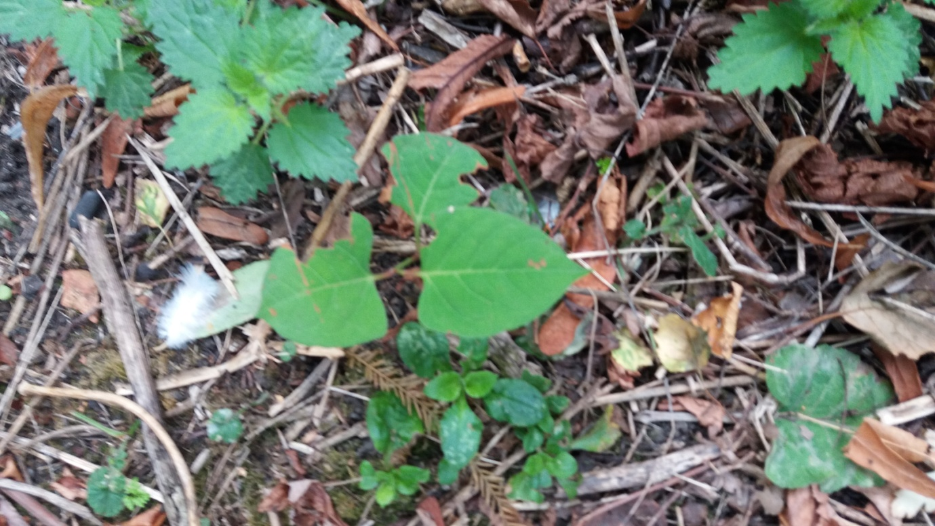
12.3 Red eared terrapins
These need to be trapped and re-homed in a terrapin sanctuary.
12.4 Gulls
Predating on the chicks – More plant and reed cover.
12.5 Foxes
Foxes are undesirable in the deer enclosure as they can bring litter and their dens can cause damage to the deer’s’ legs. Apart from this, foxes are attractive animals that many park users enjoy seeing.
- Interpretation - Suggestions for raising public awareness
To be considered in the context of CPUG’s overall interpretation strategy.
Signboards that give information on
- Tree species in the park
- Insect species in the woods
- Wildfowl species on the ponds
- Butterfly species in and outside the dome
- Wildflower species in the wildflower meadow
- Dragonflies and damselflies on the New River
A ‘recent sightings’ board by the house for birdwatchers to add their sightings (some sort of security would be needed to prevent graffiti).
A council map of green spaces in the borough and how they can be accessed.
Interpretation associated with the 20 best trees in the park.
Springfield Park might provide a model for these boards. They will raise awareness of the biodiversity in the park that at present goes largely unrecognised.
- Additional suggestions – subject to funding and further consultation
Railings along the path along the New River to prevent disturbance to wildlife.
An area set aside as a nature reserve for wildlife.
- Acknowledgements
Hackney BAP 2012/17
Annie Chipchase - Recommendations for Biodiversity Improvements - October 2016
Richard Crawford - Recommendations for Biodiversity and Interpretation - October 2016.
All photos by LP unless otherwise stated.
- Next steps
The next step is to translate these recommendations into a working management plan with a work schedule, site plan and actions for every season.

Laurence Pinturault
Interim Clissold Park Manager
Draft V2 - 9/12/2016
Ends.

